Arena Assembly Manual

Parts
Part | Photo | Qty
Black Wood Planks | 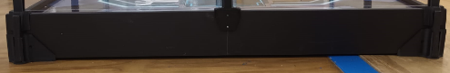 | 4
Side Walls | 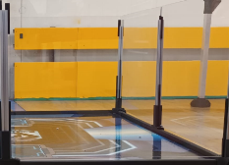 | 8
Aluminium Extrude Wall Corner | 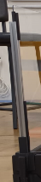 | 4
Aluminium Extrude Wall Side | 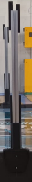 | 4
Wall Spacers | 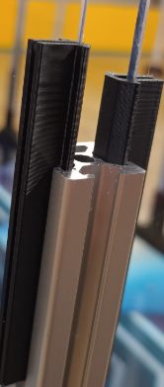 | 50+
Arena Floorboard | 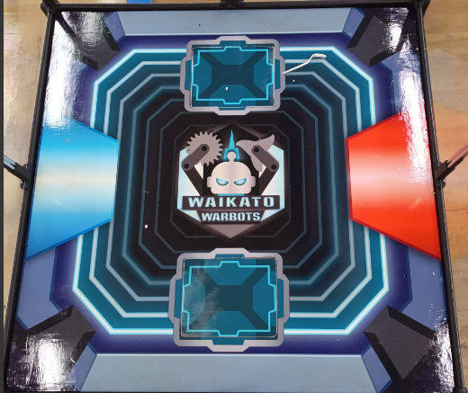 | 1
Arena Floorboard Obstacles |  | /
Swap Cat |  | /
Arena Cover | 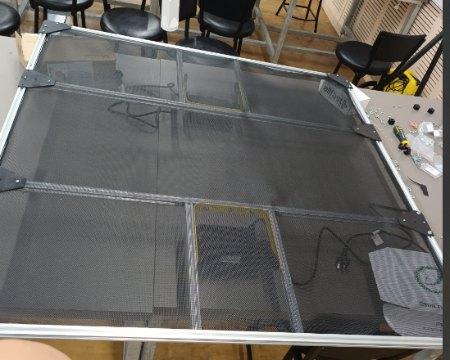 | 1
Floodlights | 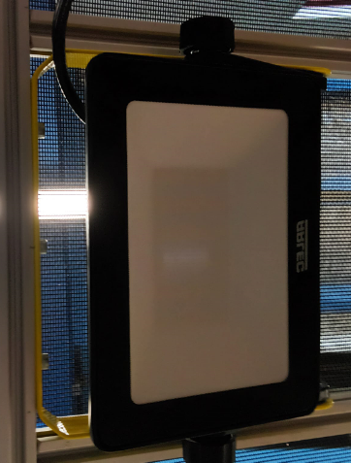 | 2
LED Band | 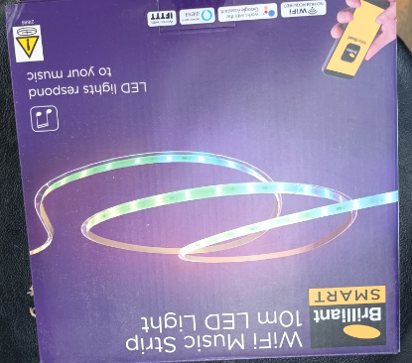 | 1
Arena Legs | 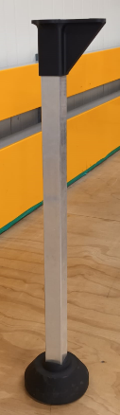 | 4
Wood Screw 16mm | 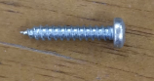 | 8

Tools
Phillips Head Screwdriver
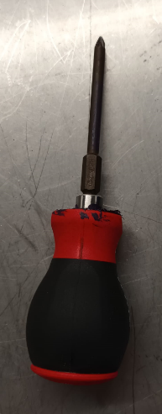

Assembly

Begin by assembling the arena floor.
To do this, line up the four Black Wood Planks in a square formation, slotting the cutouts into each other. Ensure the sloped wooden extrusion is on the inside of the square that is formed, and the flat part pointing upwards, this will be where the Arena Floorboard rests.
Place the Arena Floorboard onto these extrusions and ensure they are flat.
Next, slot the Aluminium Extrude Wall Corner onto the corners where the Black Wood Planks cross over. Line up the Aluminium Extrude Wall Side pieces in a way where the holes of their mount components line up with the pre-drilled holes in the middle of the Black Wood Planks. Screw these in using the Wood Screws 16mm.
Slide a Wall Spacer into all the Aluminium Extrude where a Side Wall will slot in.
Slot the Side Walls into these Wall Spacers. Slide another Wall Spacer into the Aluminium Extrude to hold the Side Walls at the top of the Aluminium Extrude.
Carefully lift the assembled part of the arena and slot the tops of the legs onto the bottom corners of the Black Wood Planks. Ensure the Arena is stable.
Slot in your desired obstacle, these can be changed during the workshop using the Swap Cat, which has a magnet inside it for easy removal.
Flip the Arena Cover so the mesh is on the floor. Mount the Floodlights in the middle of the outside bars, between the two parallel bars. The Floodlights will be pointing into the arena, adjust their angle as desired.
Loop the LEDs around the top of the arena, on the outside and inside.
Place the Arena Cover onto the Arena Walls in a way where the Wall Spacers slot onto the tops of the Arena Walls. Ensure there are two Wall Spacers at each corner, one a side, and a Wall Spacer in the middle to assist the Aluminium Extrude Wall Side in keeping the Arena Walls straight.

